**ASP .NET Core 8.0 Web API**

1. **Web Api using .Net core with Swagger**

Create a .Net core web application with API template. (Use existing application if created).

Output:

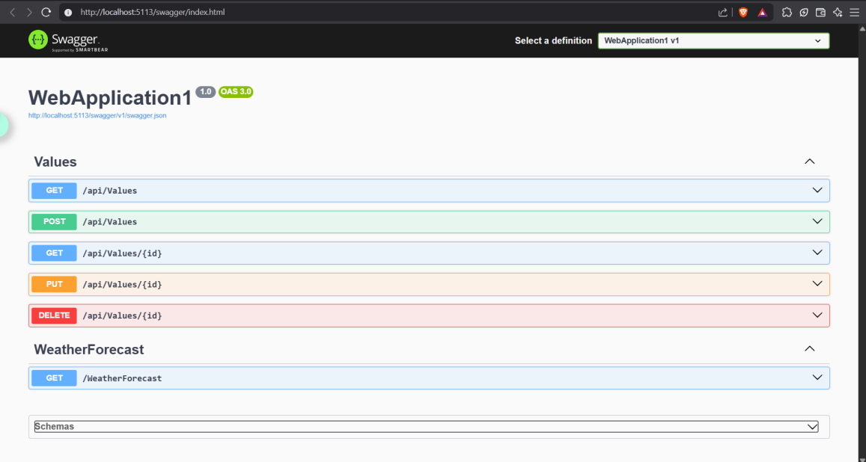

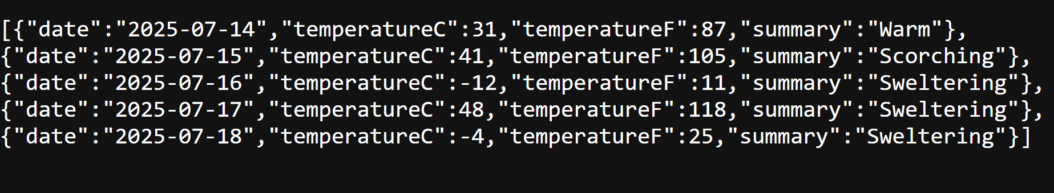

**2. Web Api using .Net core with Swagger**

Create a .Net core web application with API template. (Use existing application if created). Install Swashbuckle.AspNetCore Nuget package. Post this do the following steps in Startup.cs

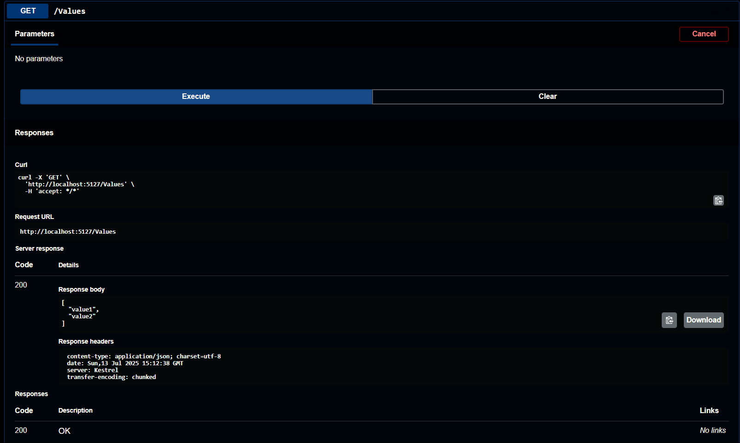

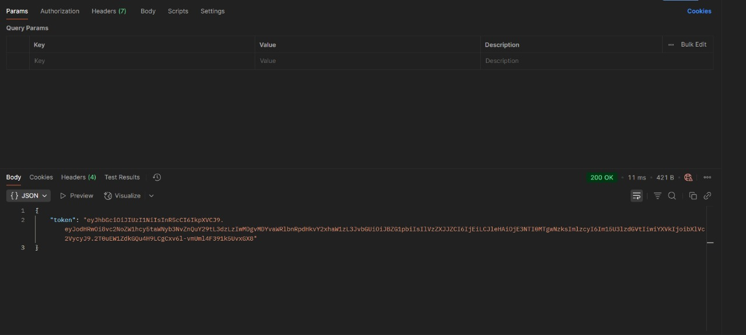

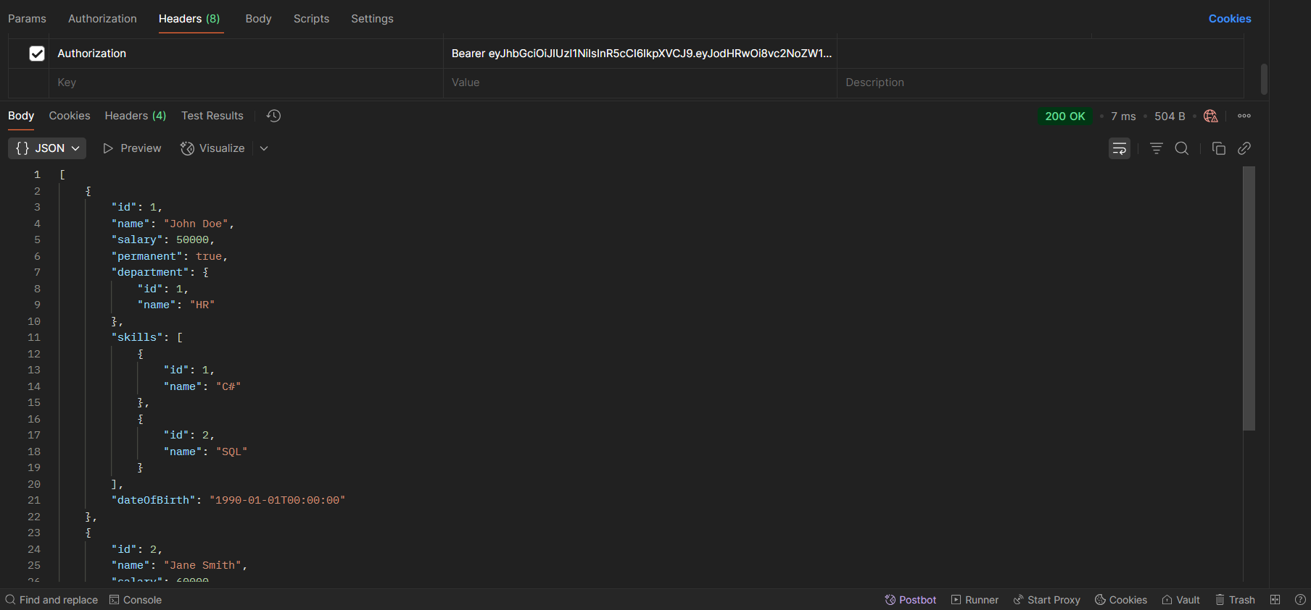

**3. Web Api using custom model class**

Create a Custom class ‘Employee’ of the below defined structure

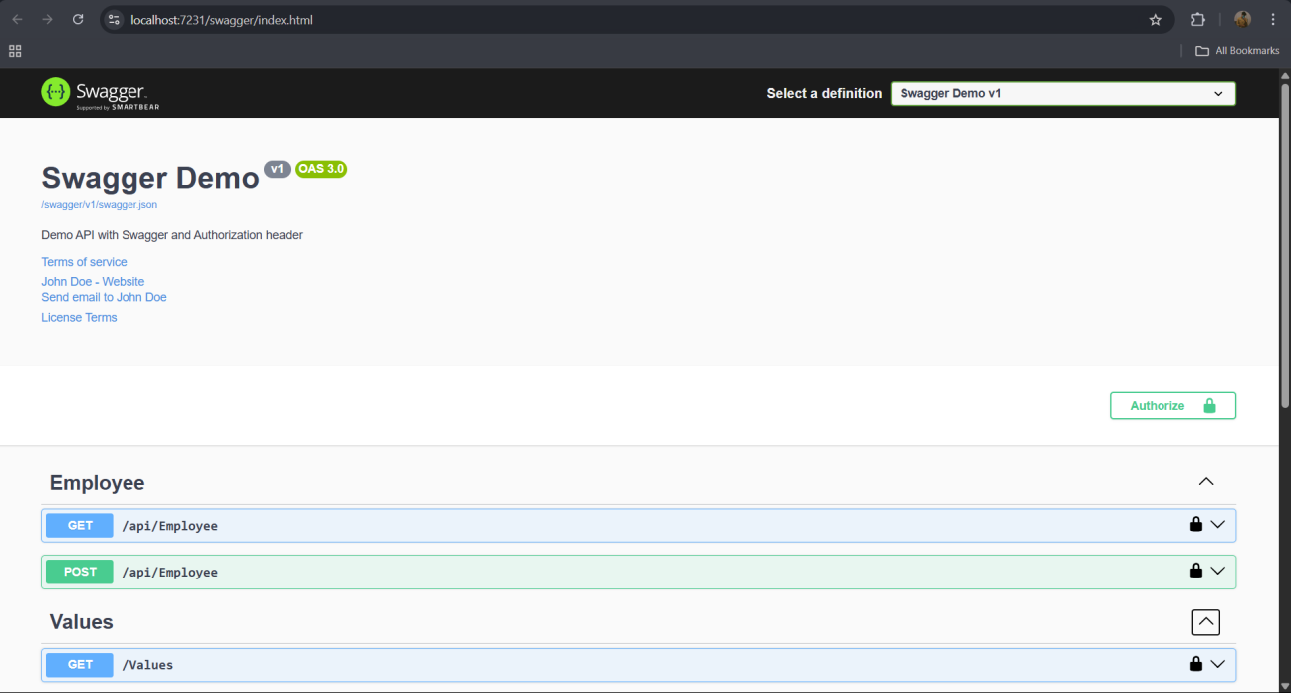

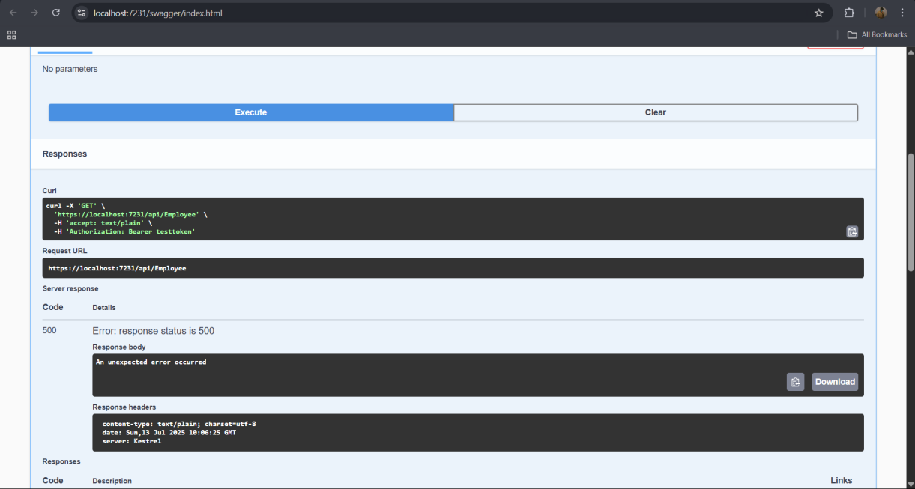

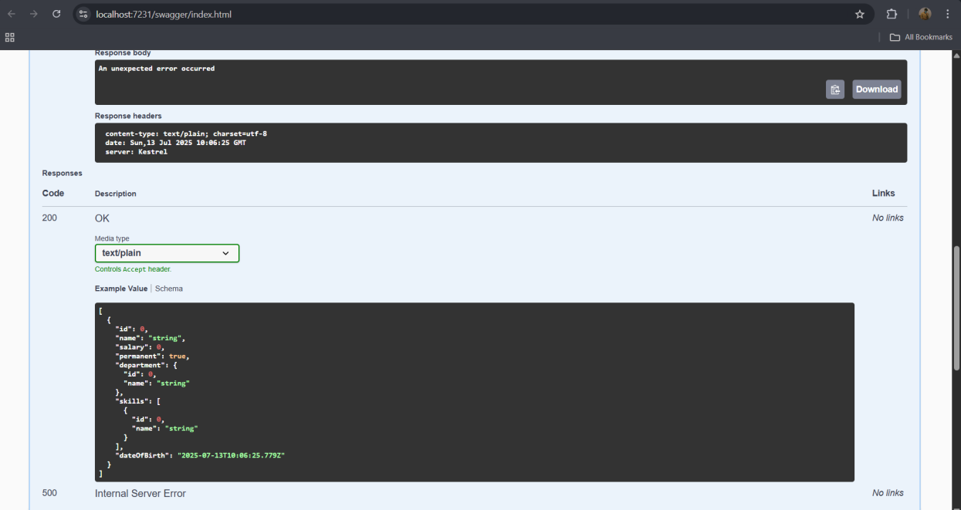

1. **Web Api CRUD operation**

Update Employee data as per the input thru Web API PUT action method call

Employee information has to be updated based on the user input. Use Swagger tool to invoke the action method mapped with Http PUT action verb to update an employee data.

Modify the action method to return Employee data thru ActionResult.

Check if the id value is lesser than or equal to 0. If true, throw BadRequest action result with the message ‘Invalid employee id’

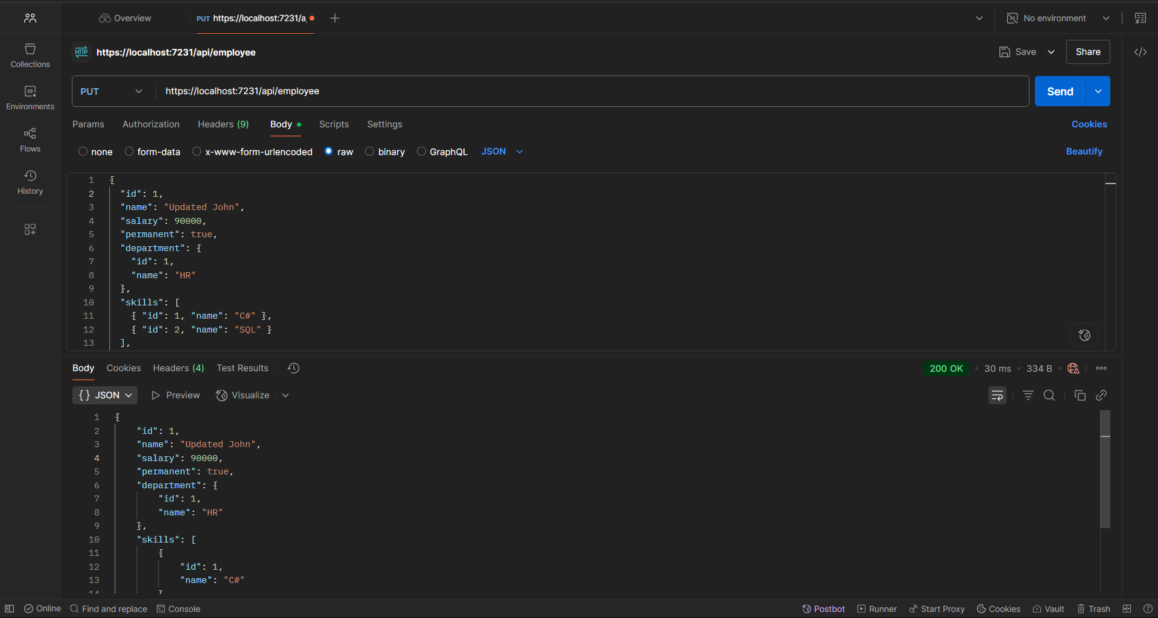

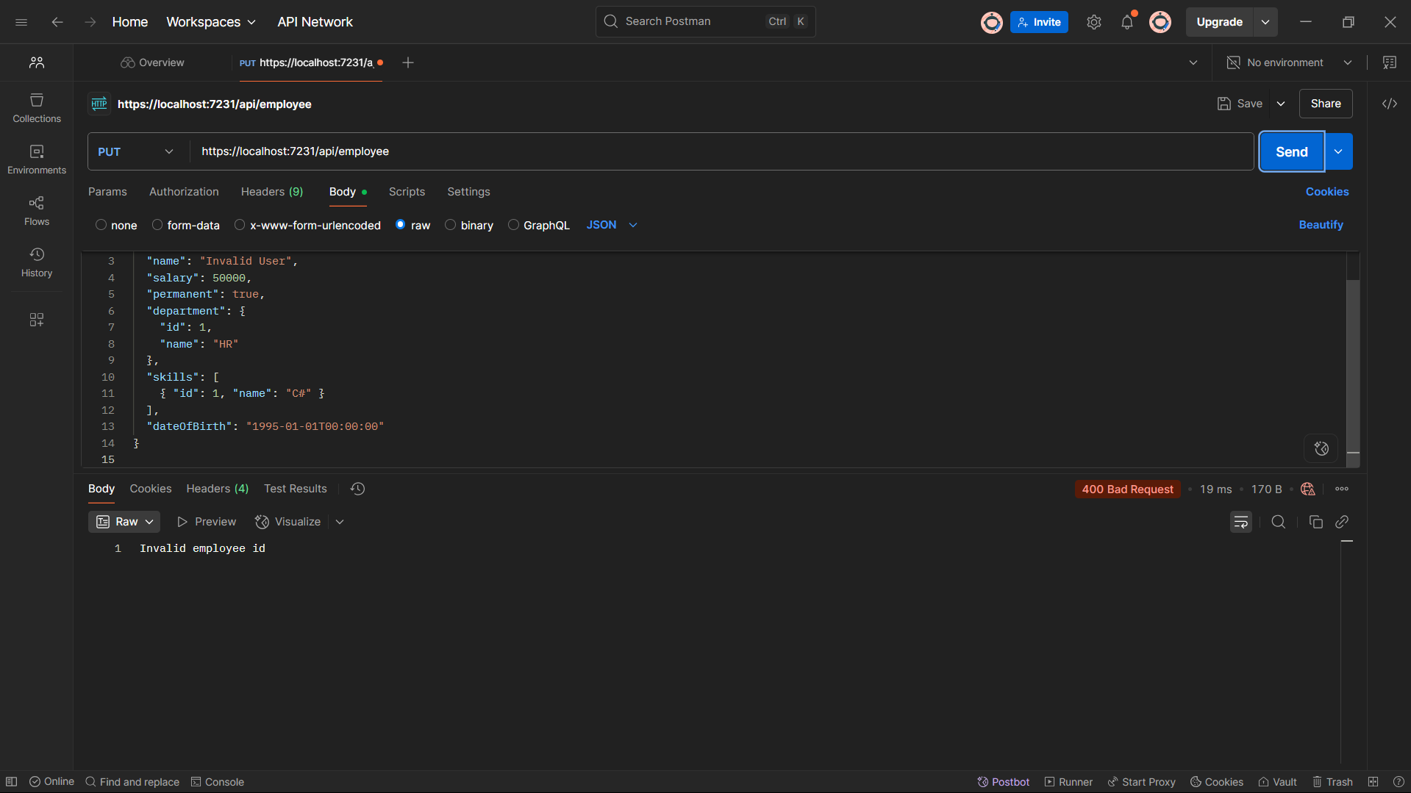

**5. JsonWebToken**

There are various modes of authenticating a request. Json Web Token(JWT) authentication is one among them. It is a methodology of passing a token in the Authorization header value in the request so that it can be checked at the WebAPI and validated. If not there, then ‘**Unauthorized**’ status message with status code 401 should be thrown.



